**Mockito Hands-On Exercises**

**Exercise 1:** Mocking and Stubbing

**Scenario:** You need to test a service that depends on an external API. Use Mockito to mock the external API and stub its methods.

**CODE:**

import static org.mockito.Mockito.*;

import static org.junit.jupiter.api.Assertions.*;

import org.junit.jupiter.api.Test;

import org.mockito.Mockito;

interface ExternalApi {

String getData();

}

class MyService {

private ExternalApi api;

public MyService(ExternalApi api) {

this.api = api;

}

public String fetchData() {

return api.getData();

}

}

public class MyServiceTest {

@Test

public void testExternalApi() {

ExternalApi mockApi = Mockito.mock(ExternalApi.class);

when(mockApi.getData()).thenReturn("Mock Data");

MyService service = new MyService(mockApi);

String result = service.fetchData();

assertEquals("Mock Data", result);

}

}

**OUTPUT:**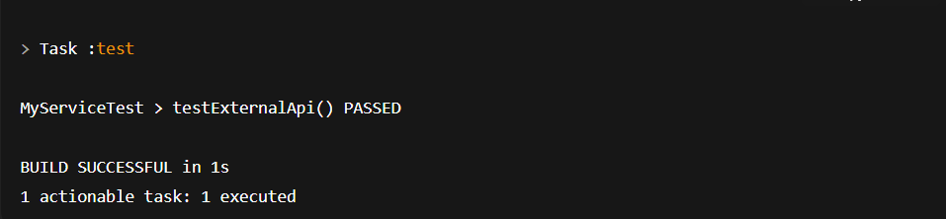

Exercise 2: Verifying Interactions

Scenario: You need to ensure that a method is called with specific arguments.

**CODE:**

public class ExternalApi {

public String getData() {

return "Real Data from API";

}

}

public class MyService {

private ExternalApi api;

public MyService(ExternalApi api) {

this.api = api;

}

public String fetchData() {

return api.getData();

}

}

import org.junit.jupiter.api.Test;

import static org.mockito.Mockito.*;

import org.mockito.Mockito;

public class MyServiceTest {

@Test

public void testVerifyInteraction() {

ExternalApi mockApi = Mockito.mock(ExternalApi.class);

MyService service = new MyService(mockApi);

service.fetchData();

verify(mockApi).getData();

}

}

**OUTPUT:**

